WEB UI – TO MAKE USER TO INTERACT WITH THE SOFTWARE
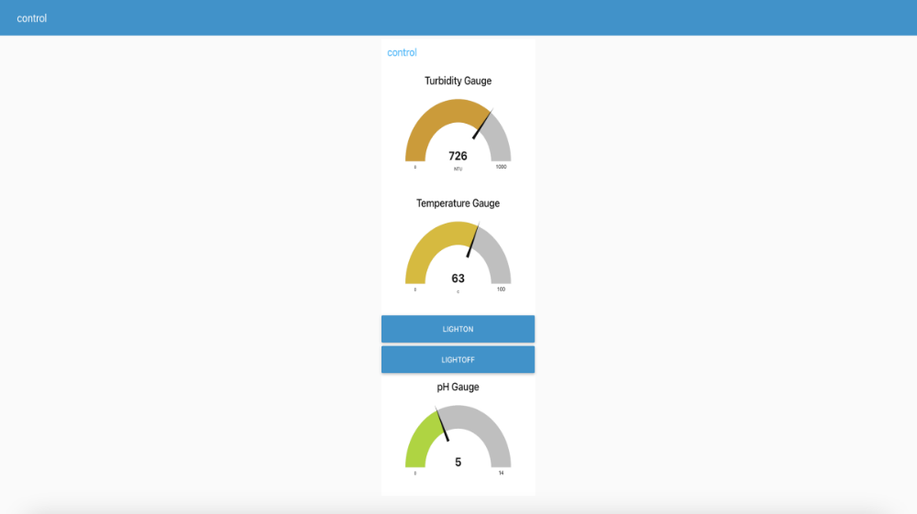

FIGURE-1: WEB UI CREATED USING NODE RED DASHBOARD

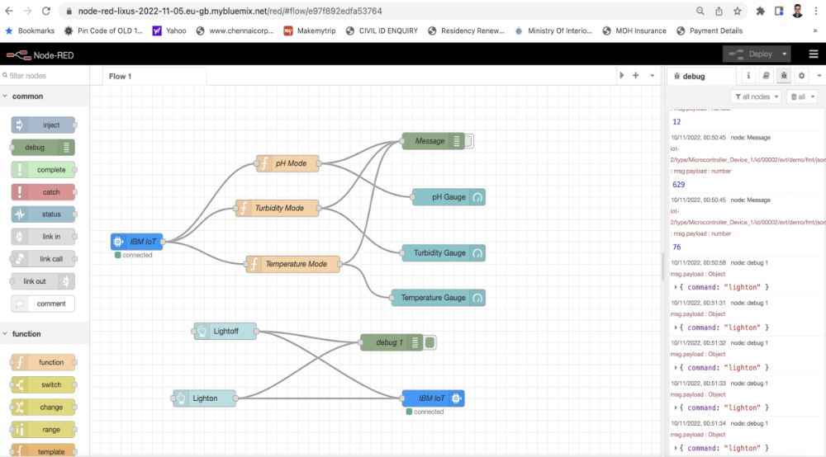
FIGURE2: WHEN THE LIGHTON BUTTON IS PRESSED

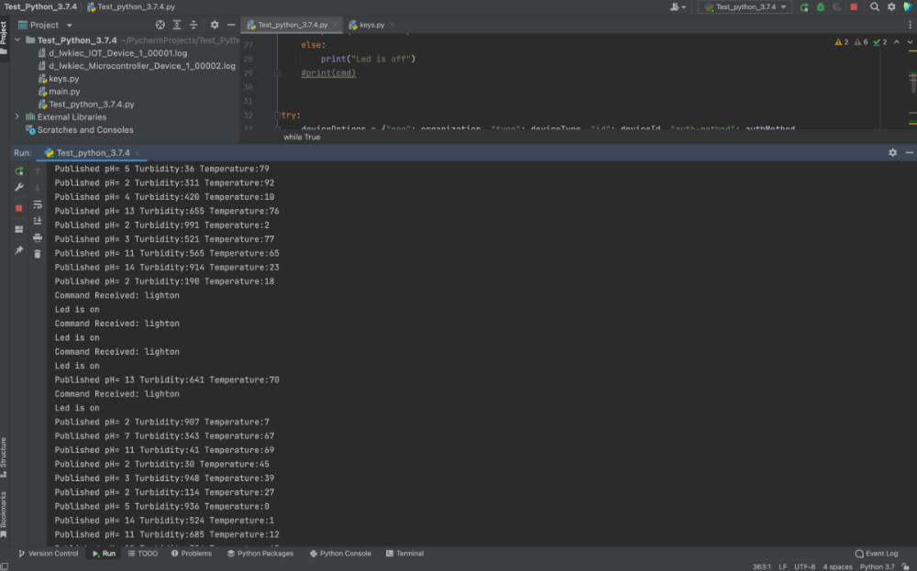
FIGURE 3: PYCHARM SOFTWARE OUTPUT CONSOLE WHEN LIGHT ON BUTTON ON WEB US IS PRESSED

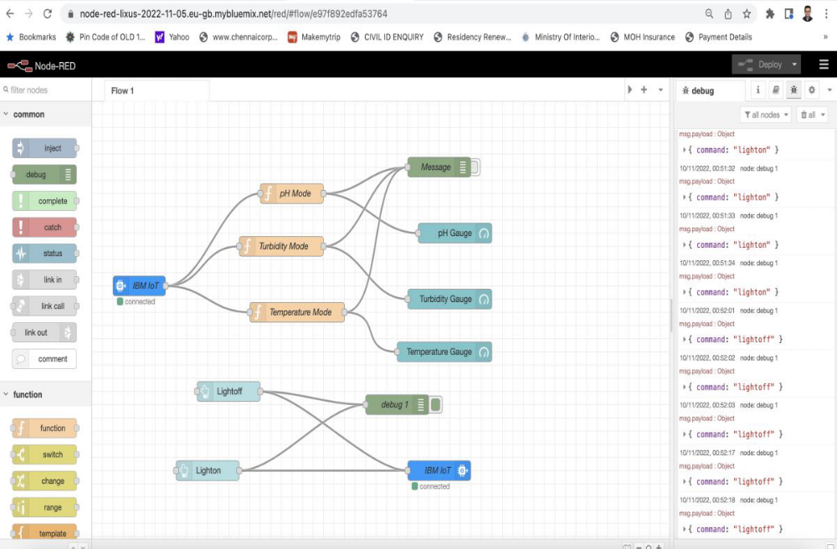
FIGURE4: WHEN LIGHTOFF BUTTON IS PRESSED ON THE WEB UI
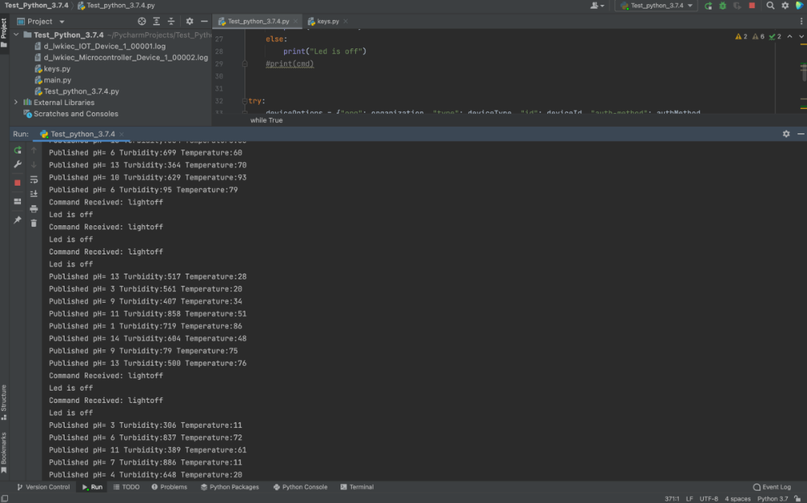

FIGURE5: PYCHARM SOFTWARE OUTPUT CONSOLE WHEN LIGHT OFF BUTTON ON WEB UI IS PRESSED

NODE RED- FINAL ARCHITECTURE- USING DASHBOARD NODES
